Assignment: Answer the following questions from chapter 3 of textbook

Name: Period: Date:

Multiple Choice questions from page 60 of textbook (Fill box with answer)

1. C.

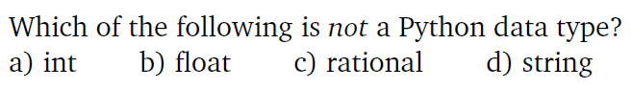

2. D.

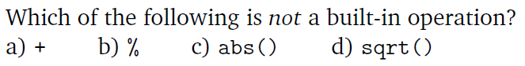

3. D.



4. B.

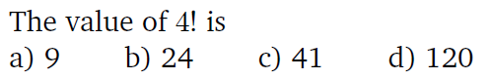

5. B.

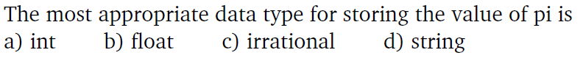

6. C.



7. D.



8. D.

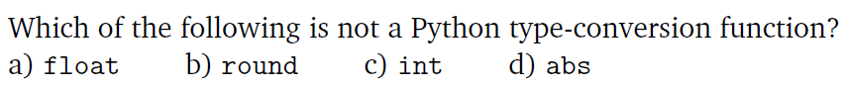

9. A.

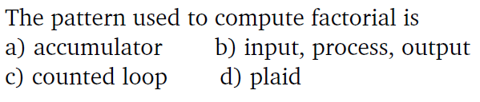

10. A.



11. Discussion question (Write output). If the expression is illegal, explain why.



7.4



5.0



18.96



sqrt is not a real function



11.0



27

12. Translate the following mathematical expressions into an equivalent Python expression.

You may assume that the math library has been imported ( import math as m )



pi = 3.14

r = 2

v = 4*pi*r**2

13. Translate the following mathematical expressions into an equivalent Python expression.

You may assume that the math library has been imported ( import math as m )



r = 2

a = 4

m = sqrt(r * math.cos(a)**2 + r * math.sin(a)**2)

14. Show the output from the following fragments:

(a) list( range(5) )

[0,1,2,3,4]

(b) list( range(3, 10) )

[3,4,5,6,7,8,9]

(c) list( range(4, 13, 3) )

[4,7,10]

(d) list(range(15, 5, -2))

[15,13,11,9,7]

(e) list( range(5, 3) )

[]

Programming Exercises

15. Name the program **length.py**

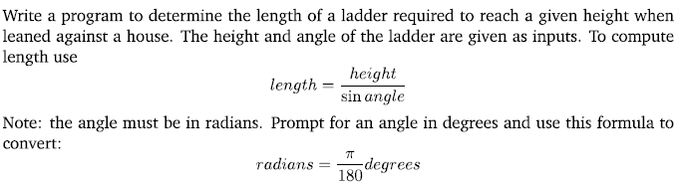

sample run ( you may want to round to 2 decimal places)

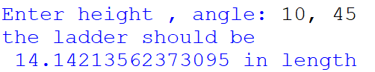

16. Write a program called **natural.py**. The program will find the sum of the first n natural numbers, where the value of n is provided by the user. (Natural numbers are positive integers starting from one)

